**The GDP and the number of Bots blocked per country**

After collection of the data, analysis was performed using SPSS. First of all, the correlations between the numbers of bots blocked per country and the gross domestic product was analyzed. The following results can be obtained:

|  |  |  |
| --- | --- | --- |
| **Test** | **Value** | **Significance** |
| Pearson correlation | 0.446 | 0.000 |
| Kendall’s tau | 0.675 | 0.000 |
| Spearman’s rho | 0.859 | 0.000 |

As seen in the table above, some correlations were found. All the tests indicate a correlation, although not every test suggests a strong one, but every test is significant. So it’s possible to say that there is indeed a correlation between the number of bots blocked in a country and the GDP of that particular country. This is also made visible when plotting this data in a graph.

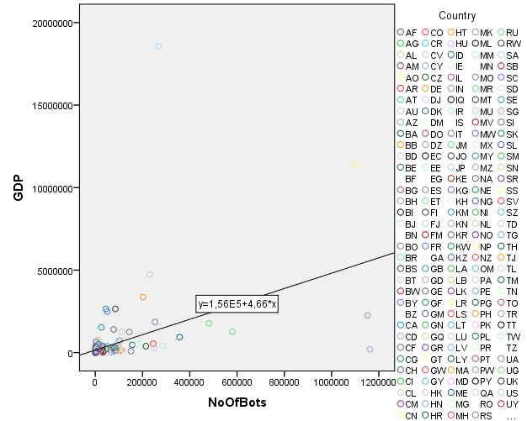

**The number of bots and the average speed**

The average speed of countries is measured in MBps and can be correlated with the number of bots blocked per country. It’s an interesting to see whether a fast or a slow internet connection will be nice conditions to host a botnet. The following correlations can be found.

|  |  |  |
| --- | --- | --- |
| **Test** | **Value** | **Significance** |
| Pearson correlation | -0.247 | 0.034 |
| Kendall’s tau | -0.163 | 0.040 |
| Spearman’s rho | -0.236 | 0.043 |

The values in the presented table indicate that when the internet speed increases, the number of bots blocked per country will decrease. In other words, a country with low internet speeds will host relatively more infected computers. It’s hard to say whether low speed is indeed a nice condition for botnet or it’s just because countries with high internet speed have a better infrastructure. And this infrastructure can have botnet prevention methods implemented. The correlation can be made visible with this scatter plot.

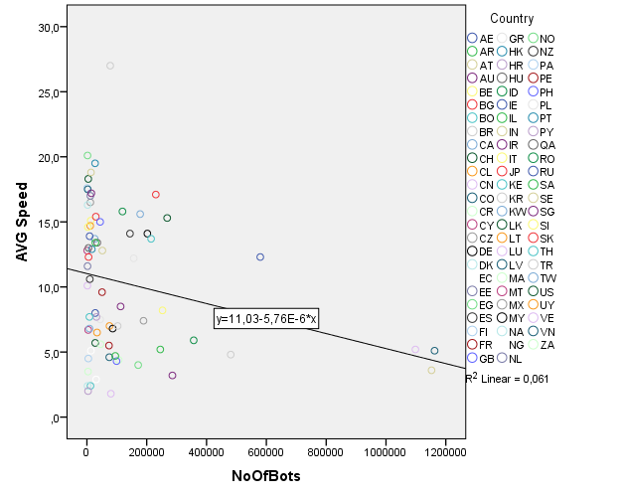

**The number of bots and the average IQ in a country**

If you’re smarter, is your computer less likely to become infected? That’s the question answered here. Combining average IQ data from all over the world with the blocked IP addresses in our data set, will give some insight. The results can be seen in the following table.

|  |  |  |
| --- | --- | --- |
| **Test** | **Value** | **Significance** |
| Pearson correlation | 0.237 | 0.002 |
| Kendall’s tau | 0.355 | 0.000 |
| Spearman’s rho | 0.485 | 0.000 |

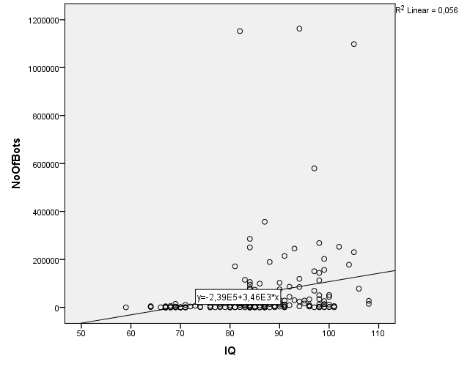A clear correlation between the average IQ and the number of bots blocked in a country can be seen. All our tests indicate a significant correlation, but not a very strong one. This means that when the average IQ of a country increases, more computers will get infected. The results of this test can be made visible with the following graph.

**The number of bots and the piracy rate in a country**

Downloading movies, music or applications illegally from the internet can cause trouble for your PC since a lot of downloads contain malware. This malware can be used to setup a botnet. So, if more people in an country call themselves online pirates, will the number in bots be higher or lower? That’s what this section is all about. The results can be seen in the following table.

|  |  |  |
| --- | --- | --- |
| **Test** | **Value** | **Significance** |
| Pearson correlation | -0.398 | 0.005 |
| Kendall’s tau | -0.409 | 0.000 |
| Spearman’s rho | -0.584 | 0.000 |

A very interesting correlation can be seen between the piracy rate in a country and the number of bots blocked in a country. The higher the piracy rate is, the lower the number of bots blocked in that particular country. All the tests indicate a significant and quite strong correlation. The results can be made visible with the following graph.

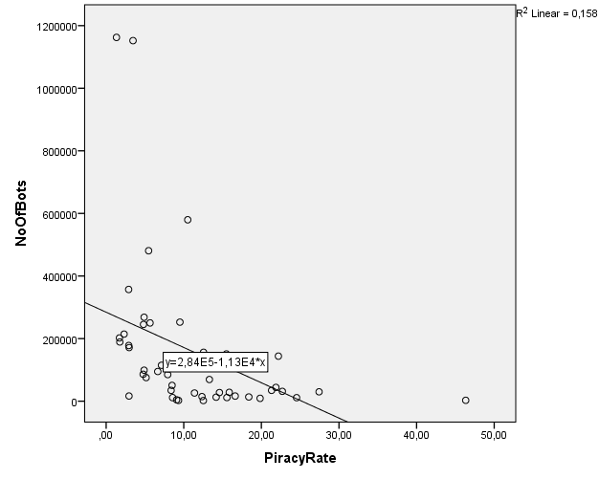

TorrentFreak. (2016). *Europe Has The Highest Online Piracy Rates, By Far*. Webite visited on 28-10-2016, via: <https://torrentfreak.com/europe-has-the-highest-online-piracy-rates-by-far-160801/>

**Correlation between factors**

All the investigated factors seem to be correlating well with the number of bots blocked per country in the given period. Therefore, it’s interesting to see whether these factors also correlate with each other, because if one factor correlates with all the others, the analysis is weakened. The correlation of all the factors can be seen In the following table.

|  |  |  |  |  |  |
| --- | --- | --- | --- | --- | --- |
| **Correlations** | | | | | |
|  | | PiracyRate | GDP | AVG Speed | IQ |
| PiracyRate | Pearson Correlation | 1 | -,200 | ,435** | ,231 |
| Sig. (2-tailed) |  | ,173 | ,**004** | ,118 |
| N | 49 | 48 | 42 | 47 |
| GDP | Pearson Correlation | -,200 | 1 | ,091 | ,274** |
| Sig. (2-tailed) | ,173 |  | ,442 | ,**000** |
| N | 48 | 184 | 73 | 170 |
| AVG Speed | Pearson Correlation | ,435** | ,091 | 1 | ,739** |
| Sig. (2-tailed) | ,**004** | ,442 |  | ,**000** |
| N | 42 | 73 | 74 | 72 |
| IQ | Pearson Correlation | ,231 | ,274** | ,739** | 1 |
| Sig. (2-tailed) | ,118 | ,**000** | ,**000** |  |
| N | 47 | 170 | 72 | 176 |
| **. Correlation is significant at the 0.01 level (2-tailed). | | | | | |

The correlation table shows clear correlations between the average speed and the GDP of a country. Not much of a surprise, since investments in infrastructure can only be paid when the GDP is high. An interesting correlation can be found between the IQ and GDP and between IQ and average internet speed. Your internet connection speed is apparently a good indicator for the average intelligence in your country. None of the factors correlate with all the other factors, so we can use them all in our analysis.

**Multiple regression model**

In the previous sections, all factors were investigated individually. In this way individual correlations can be seen, but not the actual contribution to the number of bots in a country with the other factors taken into account. Therefore, one needs to make a model with all the factors in it. This is done in this section, with use an of linear multiple regression model. In this model, the number of bots blocked in a country is chosen as a dependent variable, and IQ, piracy rate, GDP and average connection speed as independent variables. The results can be seen in the tables below.

|  |  |  |  |  |  |  |
| --- | --- | --- | --- | --- | --- | --- |
| **Coefficientsa** | | | | | | |
| Model | | Unstandardized Coefficients | | Standardized Coefficients | t | Sig. |
| B | Std. Error | Beta |
| 1 | (Constant) | -578398,774 | 160486,030 |  | -3,604 | ,001 |
| GDP | ,023 | ,010 | ,266 | 2,255 | ,030 |
| AVG Speed | -19825,679 | 4654,221 | -,753 | -4,260 | ,000 |
| IQ | 10063,619 | 2236,782 | ,765 | 4,499 | ,000 |
| PiracyRate | -3297,552 | 2140,405 | -,194 | -1,541 | ,132 |
| a. Dependent Variable: NoOfBots | | | | | | |

The most influencing factors of the number of botnets per country are the average internet speed and the average IQ of a country. Surprisingly, with all the other factors taken into account, the GDP isn’t a very influencing facto anymore. This also applies to the piracy rate of a country, which has a non-significant contribution to the amount of bots blocked per country. The model with the four factors included has a decent R value, which means that it’s able to calculate half of the values correctly, based on this factors.

|  |  |  |  |  |
| --- | --- | --- | --- | --- |
| Model | R | R Square | Adjusted R Square | Std. Error of the Estimate |
|
| 1 | ,750a | ,563 | ,516 | 101510,896 |